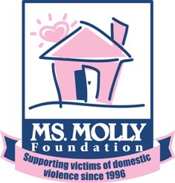
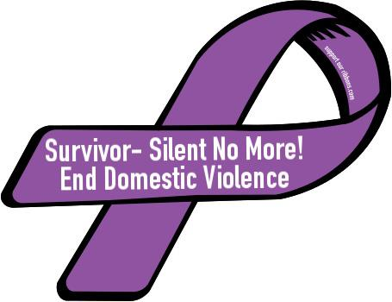
3rd Annual
5k Run/Walk to benefit
the Ms. Molly Foundation

Please join us on Saturday September 12, 2015, at Legacy Park in Cottleville, Missouri for a 5K Run/Walk to help raise funds for the Ms. Molly Foundation.
All proceeds will go to help benefit Bridgeway Women’s Shelter to help end domestic violence.
Registration begins at 6:30 AM, Race begins at 8 AM. Prizes will be awarded for the top spots in both men and women categories. Fun Run will follow the 5K.

$25 for 5K and $10 for Fun Run. Register by August 12 to guarantee shirt size. After August 12 Registration will be $30 for 5K and $15 for Fun Run with no guarantee of shirt size.

Race in memory of
Jennifer Lynn Lankford

